# Introduction

TMP36 Temperature Sensor

The TMP36 is low voltage, precision centigrade temperature sensor. It provides a voltage output that is linearly proportional to the Celsius (Centigrade) temperature. The TMP36 does not require any external calibration to provide typical accuracies of ±1°C at +25°C and ±2°C over the –40°C to +125°C temperature range. The low output impedance of the TMP36 and its linear output and precise calibration simplify interfacing to temperature control circuitry and A/D converters. It is intended for single-supply operation from 2.7 V to 5.5 V maximum. Supply current runs well below 50 µA, providing very low self-heating—less than 0.1°C in still air. In addition, a shutdown function is provided to cut supply current to less than 0.5

µA.

The TMP36 is specified from –40°C to +125°C, provides a 750 mV output at 25°C, and operates to +125°C from a single 2.7 V supply. The TMP36 is functionally compatible with the LM50. The TMP36 has an output scale factor of 10 mV/°C and it is available in low cost 3-lead TO-92, SOIC-8, and 5-lead SOT-23 surface-mount packages.

# Features

1. Low Voltage Operation (2.7 V to 5.5 V)
2. Calibrated Directly in °C
3. 10 mV/°C Scale Factor (20 mV/°C on TMP37)
4. ±2°C Accuracy over Temperature (Typ)
5. ±0.5°C Linearity (Typ)
6. Stable with Large Capacitive Loads
7. Specified –40?C to +125°C, Operation to +150°C
8. Less than 50 ?A Quiescent Current
9. Shutdown Current 0.5µA Max
10. Low Self-Heating

# Applications

1. Environmental Control Systems
2. Thermal Protection
3. Industrial Process Control
4. Fire Alarms
5. Power System Monitors
6. CPU Thermal Management

# Component List

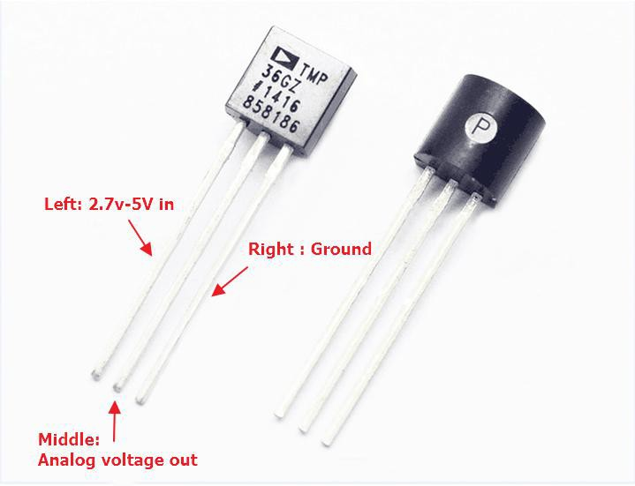

* Keywish Arduino UNO R3 mainboard
* Breadboard
* USB cable
* TMP36 module*1
* Some wires

# Wiring of Circuit

|  |  |
| --- | --- |
| Arduino UNO | TMP36 module |
| +5V | left |
| A0 | middle |
| GND | right |

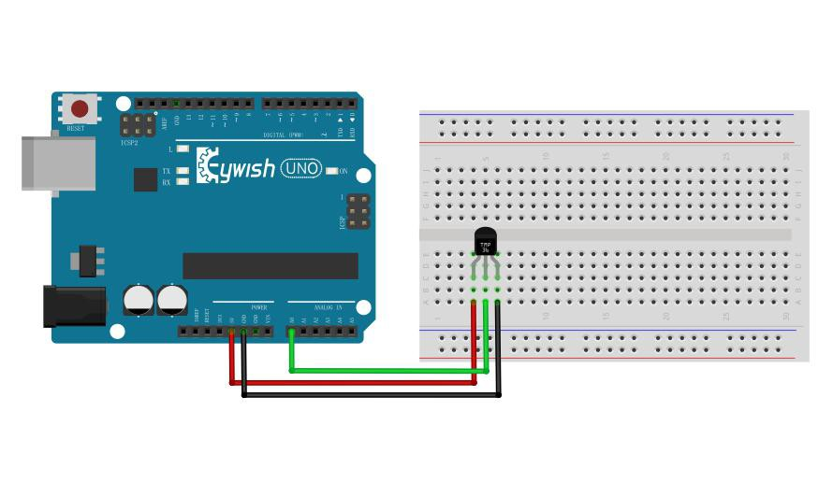

Code



int sensorPin **=** 0**;**

//the analog pin the TMP36's Vout (sense) pin is connected to

//the resolution is 10 mV / degree centigrade with a

//500 mV offset to allow for negative temperatures

void setup**()**

**{**

Serial**.**begin**(**9600**);**

//Start the serial connection with the computer

//to view the result open the serial monitor

**}**

void loop**()**

**{**

int reading **=** analogRead**(**sensorPin**);**

//getting the voltage reading from the temperature sensor

float voltage **=** reading **\*** 5.0**;**

voltage **/=** 1024.0**;**

Serial**.**print**(**voltage**);** Serial**.**println**(**" volts"**);**

float temperatureC **= (**voltage **-** 0.5**) \*** 100 **;**

//converting from 10 mv per degree wit 500 mV offset

//to degrees ((volatge - 500mV) times 100) Serial**.**print**(**temperatureC**);** Serial**.**println**(**" degrees C"**);**

float temperatureF **= (**temperatureC **\*** 9.0 **/** 5.0**) +** 32.0**;**

Serial**.**print**(**temperatureF**);** Serial**.**println**(**" degrees F"**);** delay**(**1000**);**

**}**

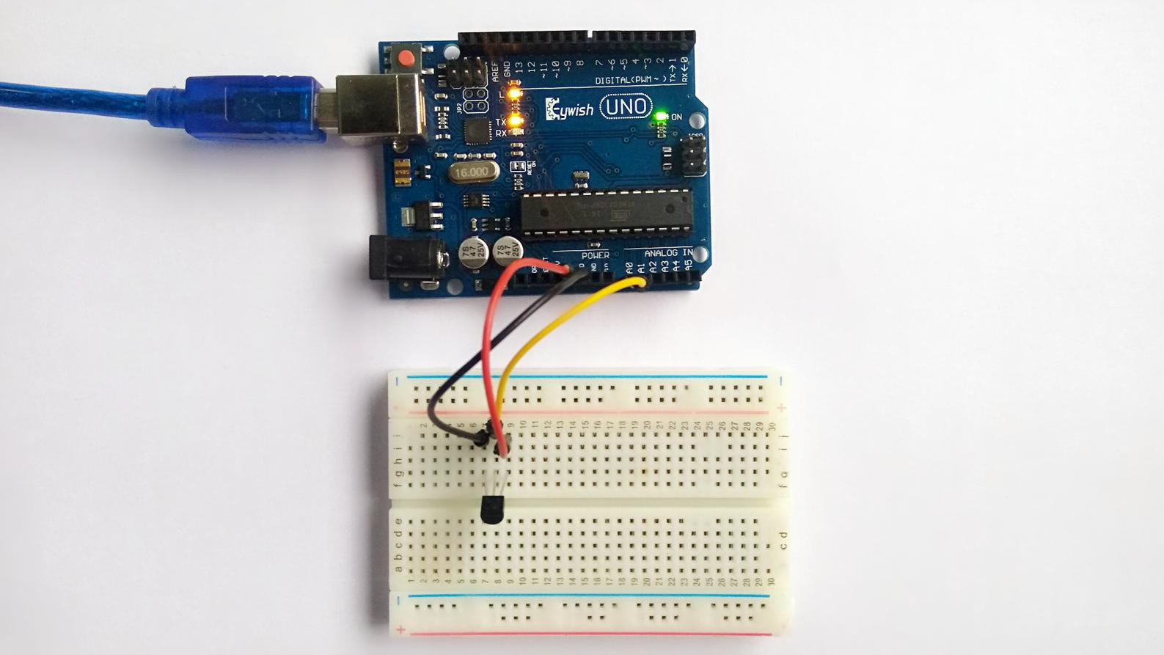

# Experiment Result

